# Normal Customer Community Portal User

These types of users are External users (E.On Customers)

While updating user details, no password reset required because PING ID is enabled for them.

**User License**: Customer Community Login

**Profile**: DA-Customer Community Login User

**KID**: nick name if no KID is provided

**Federation** ID: EGCID

**Active**: Check

**Reference user:**

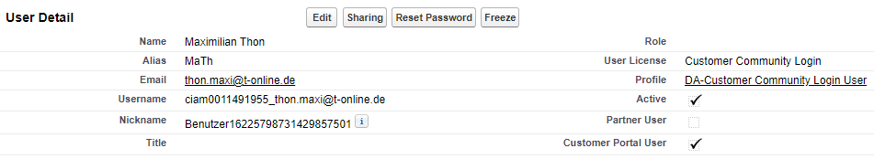



# Customer Community Plus IKU user

## Paigo Account:

<https://eon.my.salesforce.com/0011v00002yD6gk>

These types of users are Internal users.

For CCPlus IKU users, Contacts needs to get created with ‘IKU Contact’ record type.

**\*Record Type**: Contact_IKU: 0121v000000BYSK

User creation is required with following settings:

**User License**: Customer Community Plus

Profile: Customer Community Plus IKU

Active: Check

**\*Username**: Email_ID.ikuprod

Federation ID: Enter if provided otherwise either leave blank or provide any test id like: test1234

KID: Enter if provided otherwise, either enter Alias populated or last 7 digit of Federation Id if available.

While updating user details, need password reset and if still they complain about login issue, set password for them using workbench and share the credentials with them separately.

**Reference user:**

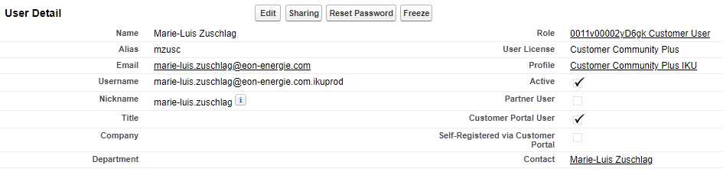

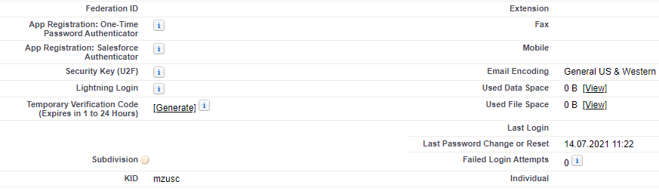

**Imp Fields for Community Users:**

* Id
* CommunityNickname
* Username
* IsActive
* IsPortalEnabled
* FederationIdentifier

**Points to remember:**

* While creating community user make sure one EGCID belongs to only one user.
* While deactivating community users all the imp fields mentioned above must get updated with some invalid entries by appending date in short if length.
* While working on community user related to Paigo account, Contact’s record type should be Contact_IKU only.
* While resetting password for any community user, check if SSO enabled with the Profile assigned.
* When user is not able to login and need password set (not reset), use workbench to do so and share the credentials separately with user so that they can login and reset the password by their own.

**Other points:**

* To enable eon external and internal users as Community users, those users should be available in Salesforce.
* When we talk about creating or enabling community users basically, we assign required profiles created for community users and map correct EGCID and KID for the community users.
* Once community users are created in Salesforce, users can login to Community portal and consume some of Salesforce community cloud features and some set of data from Salesforce.
* EGCID is created by Eon to be used by CIAM for user verification and authentication.
* There are Profiles created for Community users which allows Community users to have some set of permissions and access.
* When we create community users in Salesforce, users receive an email with password reset link.